**EW2 Report:**

Pre Amp

Gain

Filter

* Invertin
* Calcualtion

Power-Amp

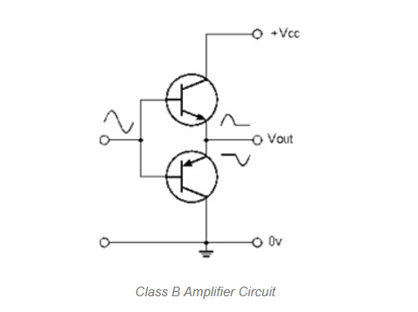

Mic and Speaker….